Практическая работа 6
Тема: «Построение дерева решений»

Цель: научиться создавать и визуализировать дерево решений для анализа и принятия оптимальных управленческих решений в различных ситуациях.

Ход работы
1. Скриншоты приложения
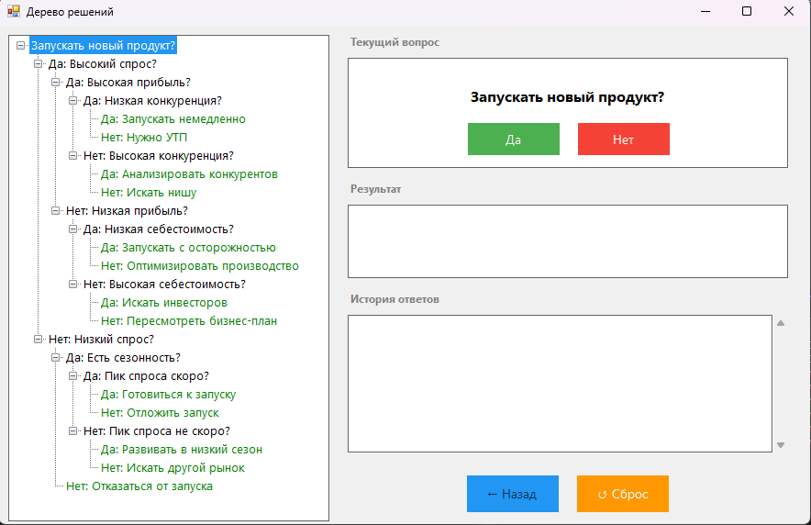
Рисунок 1 – Интерфейс приложения
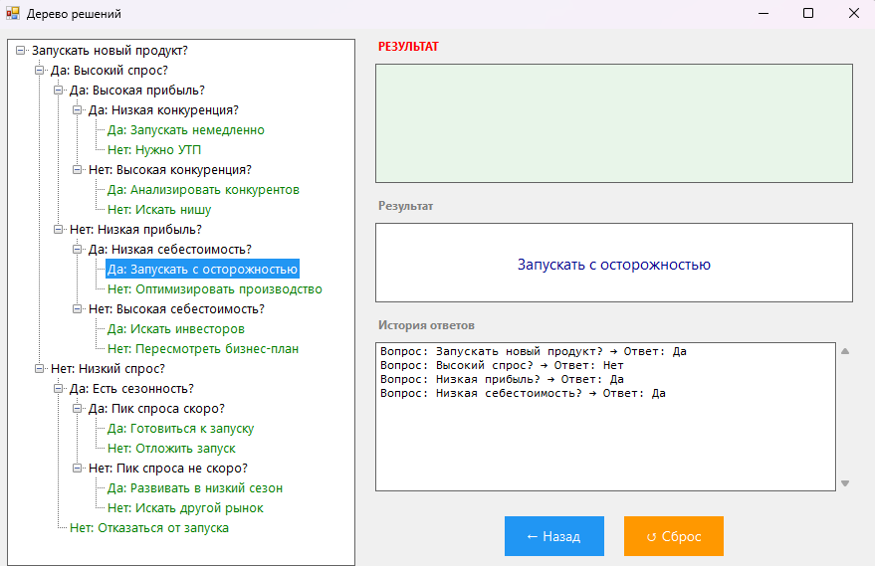
Рисунок 2 – Результат вычислений

Листинг кода

// MainForm.cs - Основная форма приложения
using System;
using System.Collections.Generic;
using System.Drawing;
using System.Windows.Forms;

namespace DecisionTreeApp
{
public partial class MainForm : Form
{
private DecisionNode rootNode;
private DecisionNode currentNode;
private List<Tuple<string, string>> history;
private TreeNode currentTreeNode;

public MainForm()
{
InitializeComponent();
InitializeDecisionTree();
history = new List<Tuple<string, string>>();
DisplayCurrentNode();
}

private void InitializeComponent()
{
this.Text = "Дерево решений";
this.Size = new Size(900, 600);
this.StartPosition = FormStartPosition.CenterScreen;
this.BackColor = Color.FromArgb(240, 240, 240);

// Левая панель - TreeView
treeView = new TreeView
{
Location = new Point(10, 10),
Size = new Size(350, 530),
Font = new Font("Segoe UI", 10),
BorderStyle = BorderStyle.FixedSingle,
BackColor = Color.White
};
treeView.AfterSelect += TreeView_AfterSelect;
this.Controls.Add(treeView);

// Правая панель
int rightPanelX = 380;

// Заголовок текущего вопроса
lblQuestionTitle = new Label
{
Text = "Текущий вопрос",
Location = new Point(rightPanelX, 10),
Size = new Size(200, 20),
Font = new Font("Segoe UI", 9, FontStyle.Bold),
ForeColor = Color.Gray
};
this.Controls.Add(lblQuestionTitle);

// Панель текущего вопроса
panelQuestion = new Panel
{
Location = new Point(rightPanelX, 35),
Size = new Size(480, 120),
BackColor = Color.White,
BorderStyle = BorderStyle.FixedSingle
};

lblQuestion = new Label
{
Location = new Point(20, 20),
Size = new Size(440, 40),
Font = new Font("Segoe UI", 12, FontStyle.Bold),
TextAlign = ContentAlignment.MiddleCenter,
AutoSize = false
};
panelQuestion.Controls.Add(lblQuestion);

btnYes = new Button
{
Text = "Да",
Location = new Point(130, 70),
Size = new Size(100, 35),
Font = new Font("Segoe UI", 10),
BackColor = Color.FromArgb(76, 175, 80),
ForeColor = Color.White,
FlatStyle = FlatStyle.Flat,
Cursor = Cursors.Hand
};
btnYes.FlatAppearance.BorderSize = 0;
btnYes.Click += BtnYes_Click;
panelQuestion.Controls.Add(btnYes);

btnNo = new Button
{
Text = "Нет",
Location = new Point(250, 70),
Size = new Size(100, 35),
Font = new Font("Segoe UI", 10),
BackColor = Color.FromArgb(244, 67, 54),
ForeColor = Color.White,
FlatStyle = FlatStyle.Flat,
Cursor = Cursors.Hand
};
btnNo.FlatAppearance.BorderSize = 0;
btnNo.Click += BtnNo_Click;
panelQuestion.Controls.Add(btnNo);

this.Controls.Add(panelQuestion);

// Заголовок результата
lblResultTitle = new Label
{
Text = "Результат",
Location = new Point(rightPanelX, 170),
Size = new Size(200, 20),
Font = new Font("Segoe UI", 9, FontStyle.Bold),
ForeColor = Color.Gray
};
this.Controls.Add(lblResultTitle);

// Панель результата
panelResult = new Panel
{
Location = new Point(rightPanelX, 195),
Size = new Size(480, 80),
BackColor = Color.White,
BorderStyle = BorderStyle.FixedSingle
};

lblResult = new Label
{
Location = new Point(20, 20),
Size = new Size(440, 40),
Font = new Font("Segoe UI", 11),
TextAlign = ContentAlignment.MiddleCenter,
ForeColor = Color.DarkBlue,
AutoSize = false
};
panelResult.Controls.Add(lblResult);
this.Controls.Add(panelResult);

// Заголовок истории
lblHistoryTitle = new Label
{
Text = "История ответов",
Location = new Point(rightPanelX, 290),
Size = new Size(200, 20),
Font = new Font("Segoe UI", 9, FontStyle.Bold),
ForeColor = Color.Gray
};
this.Controls.Add(lblHistoryTitle);

// История ответов
txtHistory = new TextBox
{
Location = new Point(rightPanelX, 315),
Size = new Size(480, 150),
Multiline = true,
ScrollBars = ScrollBars.Vertical,
Font = new Font("Consolas", 9),
BackColor = Color.White,
BorderStyle = BorderStyle.FixedSingle,
ReadOnly = true
};
this.Controls.Add(txtHistory);

// Панель управления
panelControls = new Panel
{
Location = new Point(rightPanelX, 480),
Size = new Size(480, 60),
BackColor = Color.Transparent
};

btnBack = new Button
{
Text = "← Назад",
Location = new Point(130, 10),
Size = new Size(100, 40),
Font = new Font("Segoe UI", 10),
BackColor = Color.FromArgb(33, 150, 243),
ForeColor = Color.White,
FlatStyle = FlatStyle.Flat,
Cursor = Cursors.Hand,
Enabled = false
};
btnBack.FlatAppearance.BorderSize = 0;
btnBack.Click += BtnBack_Click;
panelControls.Controls.Add(btnBack);

btnReset = new Button
{
Text = "↺ Сброс",
Location = new Point(250, 10),
Size = new Size(100, 40),
Font = new Font("Segoe UI", 10),
BackColor = Color.FromArgb(255, 152, 0),
ForeColor = Color.White,
FlatStyle = FlatStyle.Flat,
Cursor = Cursors.Hand
};
btnReset.FlatAppearance.BorderSize = 0;
btnReset.Click += BtnReset_Click;
panelControls.Controls.Add(btnReset);

this.Controls.Add(panelControls);
}

// Элементы управления
private TreeView treeView;
private Label lblQuestionTitle;
private Panel panelQuestion;
private Label lblQuestion;
private Button btnYes;
private Button btnNo;
private Label lblResultTitle;
private Panel panelResult;
private Label lblResult;
private Label lblHistoryTitle;
private TextBox txtHistory;
private Panel panelControls;
private Button btnBack;
private Button btnReset;

private void InitializeDecisionTree()
{
// Построение дерева решений согласно заданию
rootNode = new DecisionNode { Question = "Запускать новый продукт?" };

// Ветка "Да" - Высокий спрос
var highDemand = new DecisionNode { Question = "Высокий спрос?", Parent = rootNode };
rootNode.YesNode = highDemand;

// Высокий спрос → Да
var highProfit = new DecisionNode { Question = "Высокая прибыль?", Parent = highDemand };
highDemand.YesNode = highProfit;

// Высокая прибыль → Да
var lowCompetition = new DecisionNode { Question = "Низкая конкуренция?", Parent = highProfit };
highProfit.YesNode = lowCompetition;

lowCompetition.YesNode = new DecisionNode { Result = "Запускать немедленно", Parent = lowCompetition };
lowCompetition.NoNode = new DecisionNode { Result = "Нужно УТП", Parent = lowCompetition };

// Высокая прибыль → Нет
var highCompetition = new DecisionNode { Question = "Высокая конкуренция?", Parent = highProfit };
highProfit.NoNode = highCompetition;

highCompetition.YesNode = new DecisionNode { Result = "Анализировать конкурентов", Parent = highCompetition };
highCompetition.NoNode = new DecisionNode { Result = "Искать нишу", Parent = highCompetition };

// Высокий спрос → Нет
var lowProfit = new DecisionNode { Question = "Низкая прибыль?", Parent = highDemand };
highDemand.NoNode = lowProfit;

// Низкая прибыль → Да
var lowCost = new DecisionNode { Question = "Низкая себестоимость?", Parent = lowProfit };
lowProfit.YesNode = lowCost;

lowCost.YesNode = new DecisionNode { Result = "Запускать с осторожностью", Parent = lowCost };
lowCost.NoNode = new DecisionNode { Result = "Оптимизировать производство", Parent = lowCost };

// Низкая прибыль → Нет
var highCost = new DecisionNode { Question = "Высокая себестоимость?", Parent = lowProfit };
lowProfit.NoNode = highCost;

highCost.YesNode = new DecisionNode { Result = "Искать инвесторов", Parent = highCost };
highCost.NoNode = new DecisionNode { Result = "Пересмотреть бизнес-план", Parent = highCost };

// Ветка "Нет" - Низкий спрос
var lowDemand = new DecisionNode { Question = "Низкий спрос?", Parent = rootNode };
rootNode.NoNode = lowDemand;

// Низкий спрос → Да
var seasonality = new DecisionNode { Question = "Есть сезонность?", Parent = lowDemand };
lowDemand.YesNode = seasonality;

// Сезонность → Да
var peakSoon = new DecisionNode { Question = "Пик спроса скоро?", Parent = seasonality };
seasonality.YesNode = peakSoon;

peakSoon.YesNode = new DecisionNode { Result = "Готовиться к запуску", Parent = peakSoon };
peakSoon.NoNode = new DecisionNode { Result = "Отложить запуск", Parent = peakSoon };

// Сезонность → Нет
var peakNotSoon = new DecisionNode { Question = "Пик спроса не скоро?", Parent = seasonality };
seasonality.NoNode = peakNotSoon;

peakNotSoon.YesNode = new DecisionNode { Result = "Развивать в низкий сезон", Parent = peakNotSoon };
peakNotSoon.NoNode = new DecisionNode { Result = "Искать другой рынок", Parent = peakNotSoon };

// Низкий спрос → Нет
lowDemand.NoNode = new DecisionNode { Result = "Отказаться от запуска", Parent = lowDemand };

currentNode = rootNode;
BuildTreeView();
}

private void BuildTreeView()
{
treeView.Nodes.Clear();
var rootTreeNode = new TreeNode(rootNode.Question) { Tag = rootNode };
treeView.Nodes.Add(rootTreeNode);
AddNodesRecursive(rootTreeNode, rootNode);
treeView.ExpandAll();
}

private void AddNodesRecursive(TreeNode treeNode, DecisionNode decisionNode)
{
if (decisionNode.YesNode != null)
{
var yesTreeNode = new TreeNode("Да: " + decisionNode.YesNode.DisplayText)
{
Tag = decisionNode.YesNode,
ForeColor = decisionNode.YesNode.IsResult ? Color.Green : Color.Black
};
treeNode.Nodes.Add(yesTreeNode);
AddNodesRecursive(yesTreeNode, decisionNode.YesNode);
}

if (decisionNode.NoNode != null)
{
var noTreeNode = new TreeNode("Нет: " + decisionNode.NoNode.DisplayText)
{
Tag = decisionNode.NoNode,
ForeColor = decisionNode.NoNode.IsResult ? Color.Green : Color.Black
};
treeNode.Nodes.Add(noTreeNode);
AddNodesRecursive(noTreeNode, decisionNode.NoNode);
}
}

private void DisplayCurrentNode()
{
lblQuestion.Text = currentNode.Question;

if (currentNode.IsResult)
{
lblResult.Text = currentNode.Result;
lblQuestionTitle.Text = "РЕЗУЛЬТАТ";
lblQuestionTitle.ForeColor = Color.Red;
lblQuestion.Font = new Font("Segoe UI", 14, FontStyle.Bold);
panelQuestion.BackColor = Color.FromArgb(232, 245, 233);

btnYes.Enabled = false;
btnNo.Enabled = false;
btnYes.Visible = false;
btnNo.Visible = false;
}
else
{
lblResult.Text = "";
lblQuestionTitle.Text = "Текущий вопрос";
lblQuestionTitle.ForeColor = Color.Gray;
lblQuestion.Font = new Font("Segoe UI", 12, FontStyle.Bold);
panelQuestion.BackColor = Color.White;

btnYes.Enabled = true;
btnNo.Enabled = true;
btnYes.Visible = true;
btnNo.Visible = true;
}

btnBack.Enabled = currentNode.Parent != null;
HighlightCurrentNode();
UpdateHistory();
}

private void HighlightCurrentNode()
{
// Сброс подсветки
ResetTreeNodeColors(treeView.Nodes);

// Поиск и подсветка текущего узла
currentTreeNode = FindTreeNode(treeView.Nodes, currentNode);
if (currentTreeNode != null)
{
currentTreeNode.BackColor = Color.FromArgb(33, 150, 243);
currentTreeNode.ForeColor = Color.White;
treeView.SelectedNode = currentTreeNode;
currentTreeNode.EnsureVisible();
}
}

private void ResetTreeNodeColors(TreeNodeCollection nodes)
{
foreach (TreeNode node in nodes)
{
node.BackColor = Color.White;
if (node.Tag is DecisionNode dn && dn.IsResult)
node.ForeColor = Color.Green;
else
node.ForeColor = Color.Black;
ResetTreeNodeColors(node.Nodes);
}
}

private TreeNode FindTreeNode(TreeNodeCollection nodes, DecisionNode target)
{
foreach (TreeNode node in nodes)
{
if (node.Tag == target) return node;
var found = FindTreeNode(node.Nodes, target);
if (found != null) return found;
}
return null;
}

private void UpdateHistory()
{
txtHistory.Text = "";
foreach (var item in history)
{
txtHistory.Text += $"Вопрос: {item.Item1} → Ответ: {item.Item2}\r\n";
}
}

private void BtnYes_Click(object sender, EventArgs e)
{
if (currentNode.YesNode != null)
{
history.Add(new Tuple<string, string>(currentNode.Question, "Да"));
currentNode = currentNode.YesNode;
DisplayCurrentNode();
}
}

private void BtnNo_Click(object sender, EventArgs e)
{
if (currentNode.NoNode != null)
{
history.Add(new Tuple<string, string>(currentNode.Question, "Нет"));
currentNode = currentNode.NoNode;
DisplayCurrentNode();
}
}

private void BtnBack_Click(object sender, EventArgs e)
{
if (currentNode.Parent != null)
{
// Удаляем последнюю запись из истории
if (history.Count > 0)
history.RemoveAt(history.Count - 1);

currentNode = currentNode.Parent;
DisplayCurrentNode();
}
}

private void BtnReset_Click(object sender, EventArgs e)
{
currentNode = rootNode;
history.Clear();
DisplayCurrentNode();
}

private void TreeView_AfterSelect(object sender, TreeViewEventArgs e)
{
// Можно добавить навигацию по клику на узел дерева
}
}
}

